**The Land Freight Lifecycle Impact Calculator**

OnTrackNorthAmerica, in partnership with the University of Tennessee’s [Institute for a Secure and Sustainable Environment](https://isse.utk.edu/) has gathered data on seventeen lifecycle costs and impacts of building, using, and maintaining highways for truck freight transportation versus railroads and trains. The dataset powers an online tool, the **Land Freight Lifecycle Impact Calculator**, now providing stakeholders with a ready-at-hand ability to apply the information to individual projects, systems, and regions. This is the world’s first side-by-side comparison of the lifecycle return on investment of each land freight mode.

The transportation sector significantly influences our environment and quality of life. Yet, legislators, planners, project developers, and citizens have lacked a comprehensive assessment tool for investment decisions in rail versus a highway project, even while transport infrastructure receives significant public and private-sector capital. Investment in highways to accommodate an over-reliance on trucks for moving freight continues unabated, with little grasp of that investment's actual return and costs.

Traditional cost-benefit analysis narrowly focuses on only a few factors, excluding most financial, environmental, and social concerns. OnTrackNorthAmerica’s Land Freight Lifecycle Impact Calculator is crucial for redesigning infrastructure and industrial systems for the 21st century and beyond. Given our urgent need to spur economic development while reducing the impacts of industrial systems on our challenged environments and communities, including all lifecycle costs when making investment decisions is critical.

Highway-centric freight transportation has many more impacts than the understandable focus on CO2 emissions. For instance, it takes a 27-mile convoy of trucks on the highway to move the same goods as a one-mile train on its own right-of-way. This truck congestion increases travel time for everyone and affects the entire system's reliability. Consider the difference in light pollution, an increasing problem for wildlife and humans. The goods carried by a mile train require 300 tractor-trailers, each with headlights, taillights, and side lights. The train, meanwhile, has two lights on the front of the lead locomotive and a red end-of-train device on the last railcar with reflective tape on the railcar sides. Light pollution is one of the impacts of this large number of trucks, along with their impact on air pollution, congestion, and road wear. Tire wear is now the largest source of microplastics in our oceans.

Trucks must continue their vital role in our industrial systems; however, wise multimodal investments are needed at this critical time. Unfortunately, the complete costs of transportation infrastructure are seldom estimated or paid. While the direct costs are paid via construction and shipping fees, the indirect, externalized costs are absorbed by society and the natural environment. Although some legislators and planners are attuned to rail transport’s general efficiencies and benefits, the previous lack of an analytical tool has stifled wise decision-making and sound, sustainable investments. The following chart reflects the comparative costs per ton-mile of highway and railroad shipments as identified in the Land Freight Lifecycle Impact Calculator.

**Cost Per Ton-Mile of Highway and Railroad Projects**

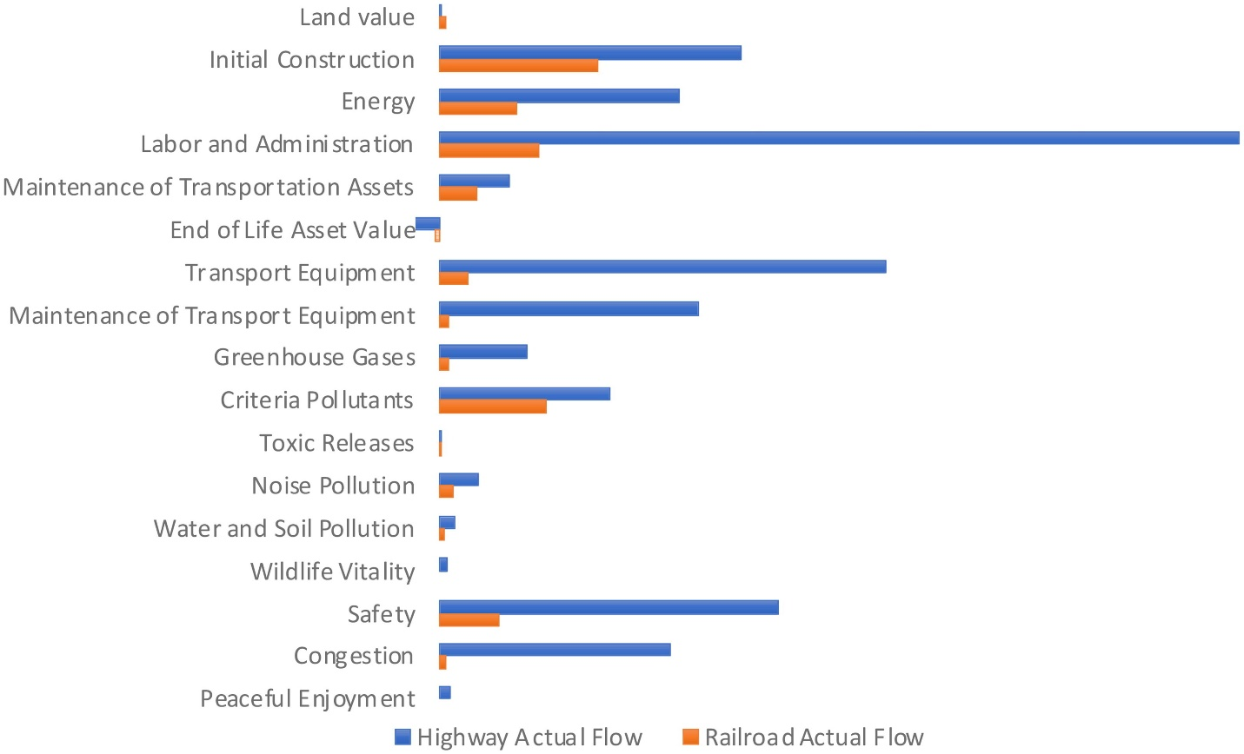

The Land Freight Lifecycle Impact Calculatorincludes data from prior research conducted in the United States. When impact factors have not been researched in the U.S., overseas research was used. These gaps need to be addressed with future primary research. The data shows that the total lifecycle cost of a highway project is approximately five times the lifecycle cost of a railroad project.

The data behind the Land Freight Lifecycle Impact Calculator will be regularly updated and disseminated, providing the infrastructure planning sector with the accurate quantitative data to inform intelligent long-term investments that best utilize each land transport mode. Adopting a complete lifecycle analysis will significantly enhance progress toward critical environmental, economic, and quality-of-life goals.